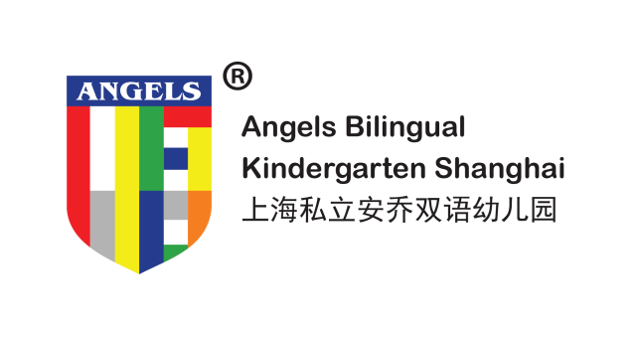

学生请假单
APPLICATION FOR LEAVE (STUDENT)
Tel: 021-59883458/59883488 Email：admission@angels.org.cn
家 长 填 写 PARENTS’ FORM | 学生姓名  NAME |  | 班级  CLASS
 | 请假日期  DATE |  |  |  | 请假天数  TOTAL NUMBER OF DAYS
 | 自 年 月 日  FROM YY MM DD | 至 年 月 日  TO YY MM DD
请假原因 REMARKS/REASON FOR LEAVE（IF ANY） 病假SICK LEAVE 事假 PRIVATE AFFAIR LEAVE
说 明REMARKS/REASON（IF ANY）：

家长签字：
PARENT’S SIGNATURE
校 方 填 写 KINDERGARTEN’S FORM | 收件日期： 年 月 日  DATE RECEIVED YY MM DD  收件人签字：  RECEIVED BY :  中文老师签字：  CHINESE TEACHER’S SIGNATURE:  英文老师签名：  ENGLISH TEACHER’S SIGNATURE:  教务主任签字：  THE HEAD OF EDUCATION DEPARTMENT’S SIGNATURE:  点名人员签名：  ATTENDANCE MONITOR’S SIGNATURE:  校车管理人签字：  SCHOOL BUS MONITOR ’S SIGNATURE:  保健老师签名：  SCHOOL NURSE’S SIGNATURE:  财务部签名：  FINANCIAL DEPARTMENT’S SIGNATURE: |  |  | 园长审批  PRINCIPAL’S APPROVAL  批准YES  不批准NO  原 因REASON：  园长签字：  PRINCIPAL’S SIGNATURE
理事会审批
BOARD MEMBER’S APPROVAL
批准YES
不批准NO

理事会签字：
BOARD MEMBER’S SIGNATURE
备 注 NOTES | - 事假，需提前一个月提出书面申请，若未按照规定，将无法申请退费；  For personal leave, a written application shall be filed one month in advance. Those who do not follow the correct protocol cannot apply for a refund.  - 病假，需三级甲等医院出示就医证明；  For sick leave, a medical certificate issued by a third-grade A hospital is required.  - 每月请假不得超过5个上课日，每学期请假总计不得超过20个上课日；  Leave days shall not exceed five school days per month, and not exceed 20 school days per semester.  - 若请假未向学校申请或一学期请假总计超过20个上课日，该生就读安乔之学籍将给予候补学生。  If the child does not apply to the school for leave or has more than 20 school days leave in one semester, the student's position on the school's roll will be granted to another who is on the waiting list.

